Adam Reichenbach
12 August 2024

Big Mountain Resort Guided Capstone Project Report

Problem Statement
The Big Mountain Ski Resort in Montana has recently installed a new chair lift to increase the distribution of visitors. This has increased the operations cost by $1.5M. The goal is to examine what features should be optimized in order to increase revenue enough to meet the additional operations cost and even turn a profit. We collected and examined ski data on other resorts so that we can compare features among them in order to create and provide a predictive pricing model for ticket prices for Big Mountain.

Data Wrangling and EDA
After wrangling, cleaning, and exploring the data we scatter plot the numerical features and found that the amount of runs, chairlifts, vertical drop, amount of days have strong positive correlations and were considered for the training and testing modeling.
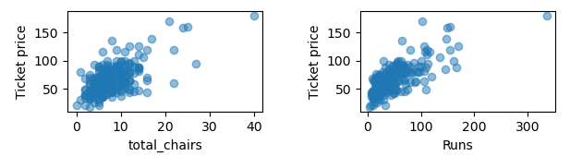
Pre-processing, training and modeling
We took our ski data and made a linear and random forest model. Random forest had less errors and variability than the linear regression. It had lower cross-validation MAE by about $1. We used the ‘learning_curve’ function to determine that a data sample size of 40-50 is sufficient.
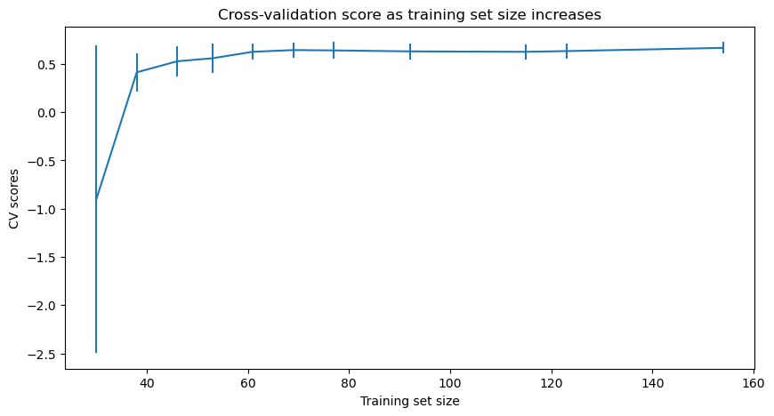
Loading the Big Mountain Resort data into our model we see there will be over $3.74M made after increasing the ticket prices by about $2, adding a run that is 150 ft lower down the mountain, and adding a chairlift to support that run. It also predicts that closing down 1 chairlift won’t make an impact on revenue. All of this predicting 350,000 visitors for the season.
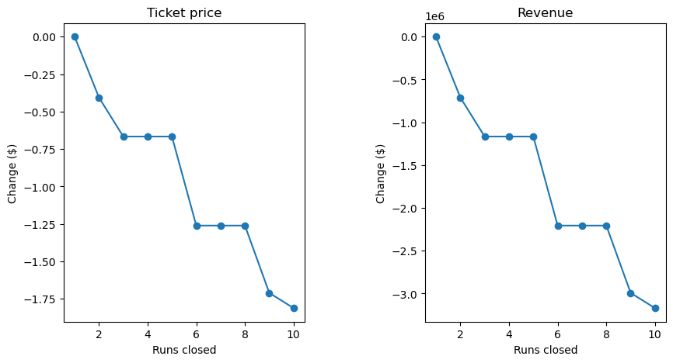

CONCLUSION
It is recommended that Big Mountain increase the ticket prices from its current price of $81 to $83, adding a run with a supporting chairlift that increases vertical drop by 150 ft, and closing down just 1 of the least used lifts/runs. Additional operation costs and visitor volume data would be recommended to help further improve the model.

